16.16: From Eq. (16.13), 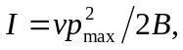 and from Eq. (19.21), 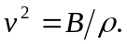Using Eq. (16.7) to eliminate 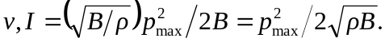 Using Eq. (16.7) to eliminate B, 